HARVELELECTRIC ELECTRONIC STORE

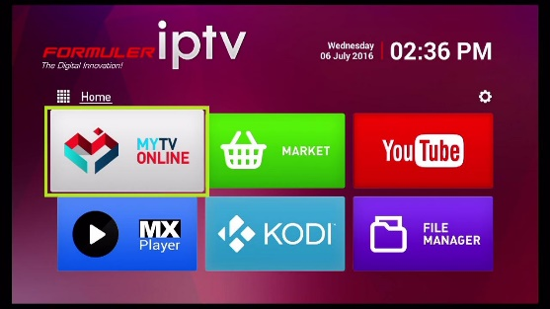

Infinix Big Screen High Quality Home Electronic Television ''43" Inch TV

Brand: [Infinix](https://www.jumia.com.ng/infinix/)

**Price: $6740**

Was ~~$7000~~ 13%

+ shipping only for V.V.I.P clients.

## **Product details**

**Infinix Big Screen High Quality Home Electronic Television ''43" Inch TV** is a classy frameless TV made just for you. The 20 watts stereo sound makes you feel like you are in a cinema. You get to hear and enjoy quality sounds from movies and music of your choice.

The over voltage protection feature ensures that your TV isn't destroyed by high voltage (or high current). With the USB media player, you can play any media in your flash or pen drive on your TV.

Unlike the panels of most TVs in the market, this TV has A+ Grade Original Panel. This means that the panel is of the highest quality you can get in the market and so you won’t have to keep going in and out of a TV repairer’s shop to fix it. In fact, when you buy this TV, you are buying peace of mind.

Warranty is 24 Months.

## **Specifications**

## **KEY FEATURES**

* Infinix Smart Ultra-HD Television
* Frameless Design
* 2*10W Full Range Speakers
* E-Remote (Compatible with Infinix Phone)
* Bluetooth 4.0

**SPECIFICATIONS**

* **SKU**: IN717EA1NCPRINAFAMZ
* **Product Line**: SP
* **Model**: X1-55 Inch
* **Weight (kg)**: 11
* **Color**: Black
* **Shop Type**: Harvel Electric Store